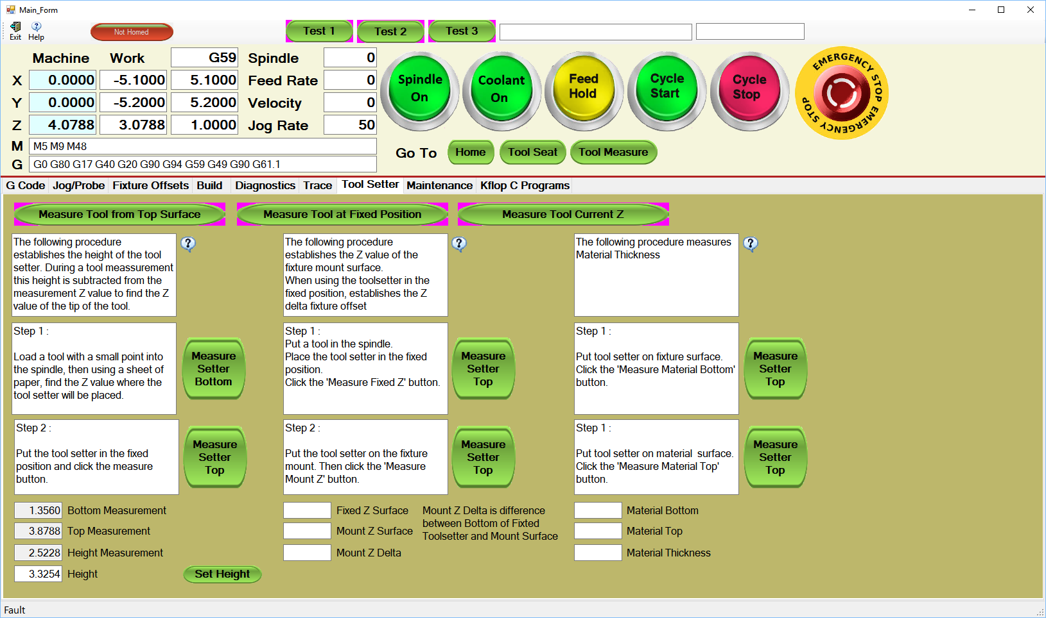

This procedure establishes the height of the tool setter. This is an important parameter because all tool measurements need the tool setter height. For example, if the tool setter is placed on top of the material to be machined, and the tool Z offset is to be measured, the routine that detects the tool setter needs to know the height. The tool setter height must be subtracted from the Z position at time of the tool setter switch actuation to find the surface of the material and thus the Z offset.

Note that you generally cannot just measure the tool setter height with a gauge because most tool setters are spring loaded and give a little before the switch engages.

Even after measuring the tool setter height with this procedure, you may want to tune in the measurement by cutting a piece of material, then measuring it. The tool setter height can then be adjusted (see next page).

The first step is to find the surface of where the tool setter is placed on. One way to do this is to put a small pointed tool in the spindle, then put a thin piece of paper on the surface. While jogging the spindle down, move the paper back and forth. When the tool touches the paper you will not be able to move it. When getting close to the paper it is best to jog incrementally at the smallest increment possible. When the tool is in the correct position click the ‘ Measure Setter Bottom’ button and the Z position will be saved.

The next step is to measure the top by jogging the tool over the middle of the tool setter, and lowering it to about ¼ inch above the setter. Click the ‘Measure Setter Top’ button and the tool will be lowered down until the tool setter switch engages, a measurement will be taken and saved, and Z retracted.

The difference in the two measurements is the tool setter height. SEE NEXT PAGE

Second measurement using tool setter.

Tool Setter

First measurement using paper.

NOTE : The height used for tool measurement is shown in the lowest text box with the ‘Height’ label. This is not automatically set when doing the measurements. The ‘Set Height’ button must be clicked. This is done this way so that the height may be adjusted, or measured in another way.

